CSCI 580 Submit
How to submit your homework

Since the assignments are connected and grow into a rendering system, it may be better to keep your previous assignments in a safe place. To submit an assignment, students should zip their workspace directory for that assignment.

Your homework’s workspace and source code for framework will be given in the homework package and must be compiling under Visual Studio Community 2019 only.

IMPORTANT:

- You can download VS from USC services for free. To download the software, go to:
https://azureforeducation.microsoft.com/devtools
Click “Sign in,” and sign in with your Microsoft account (if you don’t have one, you might need to sign up with your school email first)
2. In the next page, click “education” then “Software”, and type “Visual Studio Community 2019” in the “Search” field and download the software as shown below:
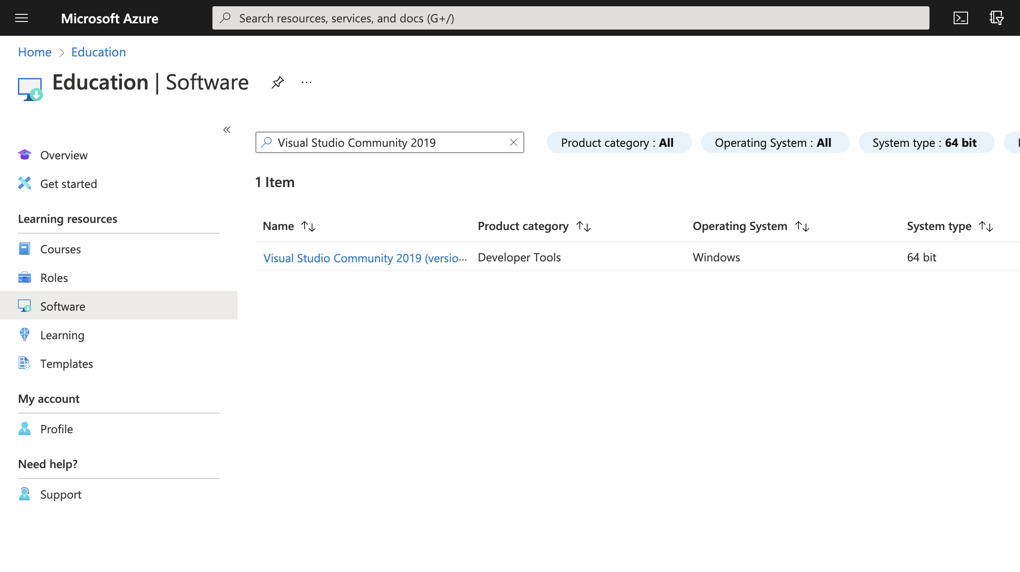
3. Open the downloaded file and follow the Visual Studio Installer to install the VS 2019. Please make sure you select the “Desktop development with C++” and add “C++ MFC for latest v142 build tools” in the “optional” list. Please also see the installation details in the picture as a reference.


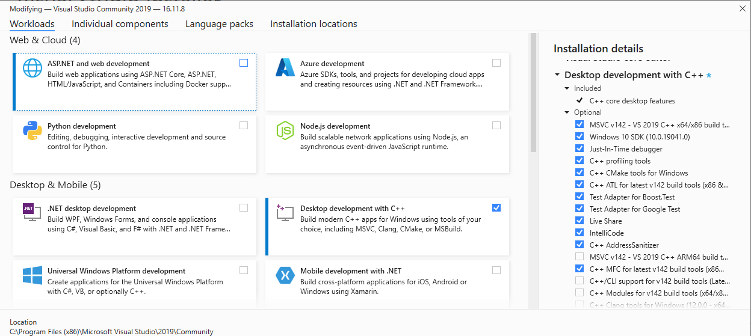

- Note : If you do not have a Microsoft computer, you can set up virtual machine ( Windows 10 installed by VirtualBox on MacOS has been tested, one of the tutorials: https://www.howtogeek.com/657464/how-to-install-a-windows-10-virtualbox-vm-on-macos/)

Here are the procedures for starting your homework in the Visual C++:

- First, in Visual C++, open the workspace file of the homework. Choose File>Open>Project/Solution

- Browse and select a workspace file (.dsw):

e.g. CS580HW1.dsw
*Note: Make sure you open the DSW file, not the DSP.v

- The Visual C++ will create the solution files for the code and try to convert the workspace file to its version (say YES to the format conversion pop-up), then save the solution.

- Next time, you can just open the solution (.sln) instead of the workspace or project.

- You are now ready to start programming, compiling, and building executables.

--> If you want to add *.cpp and *.h files, select menu “Project-> Add new item…".

- After compiling with “Build>Build solution” (or press “F7”), execute program by selecting menu “Debug>Start Debugging” (or press “F5”)

--> Default input/output files are hard coded in the source code.
(e.g. Application1.cpp -> INFILE1, OUTFILE1)

- Select File>Open to specify different input files or Render>RunRender to call the rendering function.

- Result should be shown on your display window and an “output.ppm” file should be generated simultaneously. If you do not have any software that can open a PPM file, you can download Irfanview (https://www.irfanview.com/) for free.

- Write a README file in each project directory. The README file should contain student name, ID, email address, visual studio version and any other relevant information you would like the grader to know.

- To submit assignments, compress the project directory to an appropriate file name such as LASTNAME_FIRSTNAME_HW1.zip. It is important that your homework unzips to a DIRECTORY that has your last name then first name like the same style as the zip file. If this is not the case, we will NOT GRADE your work…

Please REMOVE the Debug and/or Release folders, the ipch folder, the *.sdf file, the *.doc file and the *.ppm files before creating your zip.
The remaining files are: *.h, *.cpp, *.rc, *.dsp, *.dsw, *.sln, *.vcxproj* and the res folder.

- Submit your assignment under the "Assignments" menu of the USC Blackboard system (http://blackboard.usc.edu). Access the csci580 class of your USC black board account and click "Assignments" menu, then browse for the assignment you are about to submit. For more help regarding blackboard, check out this website:
https://studentblackboardhelp.usc.edu/coursework/

- Download your submission to a clean environment, unzip the folder and test if your solution can compile and run. If not, fix the problem and resubmit. We will only grade your latest submission.

Submission Policy

All homework must be submitted on time to be graded as scheduled. Late homework submissions will not be graded! Homework 4 provides a one-time opportunity for re-grading of previous HWs (i.e. HW1, HW2, and HW3). Students may request re-grading by stating their desire clearly in their README file. Students are encouraged to use this opportunity for catching up in the class and of raising their grades. For HW5 and HW6, no re-submission or late submission is allowed beyond their due dates.

Academic Integrity

We perform code similarity checking for ALL homework, not only among your fellow students but also across historic records and internet resources. In cases of copied code, ALL parties involved will incur deductions, without exception, and at the professor's discretion. THERE IS NO EXCUSE FOR COPIED CODE. The case will also be reported to SJACS (Student Judicial Affairs & Community Standards), which may lead to suspension or revocation of your degree.

Thanks for following these steps and good luck with your homework

